1ai)

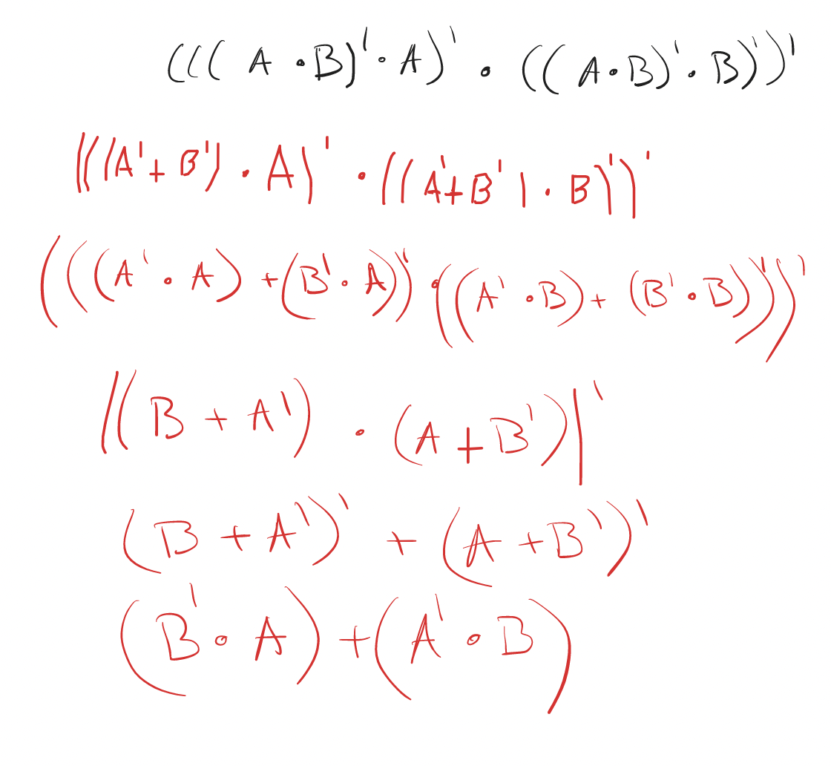

1aii) This is equivalent to an XOR gate

1di) 8G → 2^33

64 bits → 8 bytes → 2^3

Memory is 2^36 bytes (64G)

1dii) Total number of RAM chips = (8G x 64) / (512M x 4) = 256

2a)

i)

Byte at 09H = 1F  
Doubleword at 0AH = 7A FE 06 36

ii)

14 operations requires 4 bits to encode  
4 Registers requires 2 bits to encode

1K memory requires 10 bits to encode

16 bit instructions with following 2 formats

1) Reg to Reg – 4 bit opcode 2bit target Reg 2bit source Reg 8 bit unused  
 2) Reg to Mem – 4 bit opcode 2 bit target Reg 10 Bit Memory Address

Iii)

Push (add to top of stack)

Pop (remove from top of stack)

FILO / LIFO – First in Last Out / Last In First Out

iv)

2b)

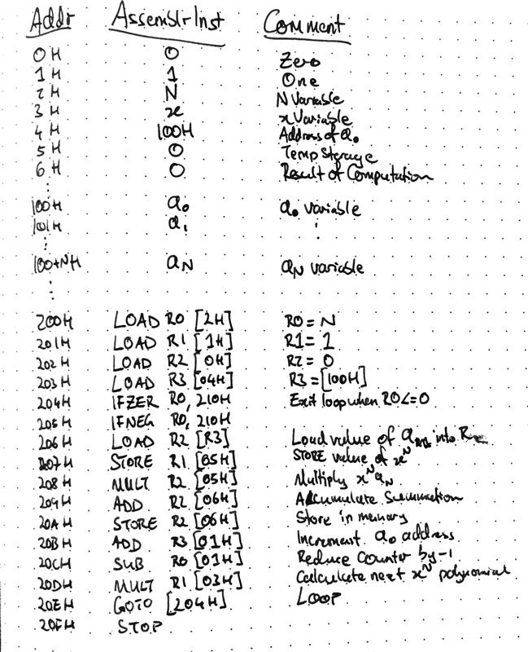  
should read:

204H IFZER R0 [20FH]  
205H IFNEG R0 [20FH]